BUSINESS STRATEGY & INVESTMENT REPORT
SkillBridge AI
AI Co-Founder & YC-Style Advisory Assessment — Source: Day 23 Blueprint
Sector | EdTech · AI · Career Development · SaaS
Market | India (primary); SE Asia & Middle East (expansion)
Stage | Pre-revenue, side project — Day 23 of validation journey
Report Date | 17 July 2026
Prepared By | Claude — AI Co-Founder, Growth & Investment Advisory

Final Verdict
🟡 VALIDATE — Real Problem, Unproven Monetization & Distribution

TABLE OF CONTENTS
1. Startup Summary & Extracted Assumptions
2. Business Reality Check
3. Executive Summary
4. Business Strategy Report
5. Investment Scorecard (0–100)
6. Visual Dashboard
7. Founder Action Sheet — Top 10 Actions
8. Sustainability Verdict

1. STARTUP SUMMARY
- SkillBridge AI is an AI-powered career guidance platform for Indian college students and fresh graduates.
- It combines career-path discovery, skill-gap analysis, personalized learning roadmaps, ATS-friendly resume building, and interview prep in one product.
- Problem: students have abundant free content but almost no personalized, one-to-one guidance on which skills/paths fit them.
- Primary customer: final-year engineering/tech students and fresh graduates (0–12 months out), Tier-2/3 India first.
- Secondary customer: career counselors, training institutes, and universities — a potential B2B2C channel.
- Stage: side project with a long-term startup vision; currently pre-revenue with no paying users or waitlist.
- Market: India's EdTech sector (~USD 3.6B in 2025, ~28% CAGR); future expansion to Southeast Asia and the Middle East.
- MVP direction: a single wedge — AI resume ATS scorer + personalized skill-gap roadmap — rather than the full six-feature vision.
- Monetization plan: freemium, one-time paid reports, monthly subscription, and future B2B2C institutional licensing.
- Biggest open risk: differentiating from free general-purpose AI tools (ChatGPT, Gemini) that can partially substitute the product.
Extracted Assumptions
Category | Assumption Extracted from Blueprint
Customer | Final-year engineering/tech students & fresh grads, Tier-2/3 India, price-sensitive, mobile-first
MVP | Resume ATS scorer + personalized skill-gap roadmap as the first wedge; full suite deferred
Value Proposition | Personalized, structured, affordable career guidance vs. generic scattered free content
Pricing | Free tier → ₹99–299 one-time report → ₹299–499/mo subscription → custom B2B2C licensing
Revenue | Assumed layered model; no revenue collected yet — entirely hypothesis-stage
GTM | Organic content, stranger interviews, landing-page waitlist, 1–2 pilot colleges, referral loop

2. BUSINESS REALITY CHECK
Who Pays?
Primarily the student, out of their own pocket — a highly price-sensitive buyer with many free alternatives already in hand. Secondarily, and unproven, institutions (colleges/training institutes) could pay via a B2B2C license, which is typically a more durable revenue source but requires relationships that don't exist yet.
Why Do They Pay?
Not because the information doesn't exist elsewhere — it does, for free. They pay for the removal of decision paralysis at an anxious, time-pressured moment (placement season, a rejection, a viral AI-job-fear post), and for a credible, personalized answer instead of one more generic video. This emotional/urgency trigger is the real purchase driver, not the AI technology itself.
How Will They Discover the Product?
Currently assumed via organic social content, campus word-of-mouth, and 1–2 pilot colleges — no paid acquisition budget or channel has been tested. This is the single least proven part of the plan.
Biggest Growth Risks
Risk | Why It Matters
No proven distribution channel | Organic + referral growth is unpredictable and slow to compound without an initial spark
No institutional relationships | The likely-more-durable B2B2C channel is entirely untested
High CAC if paid acquisition is needed | Students are expensive to reach individually and convert at low ARPU
Solo-founder execution bandwidth | Side-project status limits the speed at which channels can be tested
Biggest Monetization Risks
Risk | Why It Matters
Extreme price sensitivity | Indian students default to free tools; even ₹99–299 is a real objection point
“Why not just use ChatGPT?” | The product must visibly out-perform a free general AI tool in the first session
One-time-to-recurring conversion is unproven | A ₹99 report buyer may not convert into a ₹299–499/month subscriber
B2B2C sales cycle risk | Institutional deals are slow, relationship-driven, and unproven as a channel
Weakest Assumptions to Validate First
- That students will pay anything for AI guidance rather than using free tools they already trust.
- That organic content and referral loops can generate enough volume without a paid channel.
- That personalization is a defensible moat rather than a thin wrapper around a general AI model.
- That the B2B2C institutional channel is realistically sellable by a solo, early-stage founder.

3. EXECUTIVE SUMMARY
SkillBridge AI addresses a genuine, well-documented pain point — Indian students lack personalized career guidance — inside a large, fast-growing market. The idea is directionally sound and the founder has strong personal proximity to the problem. However, as a business rather than a product idea, it remains unproven on the two dimensions investors and sustainable operators care about most: will someone actually pay, and can the company acquire customers at a cost lower than what they pay. Distribution today rests entirely on unproven organic/referral assumptions, and the monetization model has never been tested with real money changing hands.
This is not a reason to abandon the idea — it is a reason to treat the next 30–60 days as a business-model validation sprint, not an engineering sprint. The recommended path is to prove willingness-to-pay and a repeatable acquisition motion at small scale before any meaningful investment of capital or full-time effort.
VERDICT: 🟡 VALIDATE
Do not scale spend or seek investment yet. Prove that real students will pay real money through a channel that can be repeated — then this becomes an investable business rather than a promising idea.

4. BUSINESS STRATEGY REPORT
4.1 Business Model Canvas
Block | Summary
Value Proposition | Personalized AI career path + skill-gap roadmap + ATS resume + interview prep in one affordable product
Customer Segments | Final-year engineering/tech students & fresh grads (primary); counselors, institutes, universities (secondary)
Channels | Organic social content, stranger interviews, landing-page waitlist, pilot colleges, referral loop
Customer Relationships | Self-serve freemium product with milestone nudges; light-touch human support at premium tier
Key Activities | AI roadmap/resume engine development, content marketing, campus pilots, iteration on conversion
Key Resources | AI/LLM API access, India-specific job-market data, founder's student network
Key Partners | Pilot colleges/placement cells, potential AI API providers, future training-institute partners
Cost Structure | AI/API usage costs, content production, founder time — lean, no team currently
Revenue Streams | One-time paid reports, monthly subscription, future B2B2C institutional licensing
4.2 Revenue & Pricing Strategy
Tier | Price | Included
Free | ₹0 | Career-path assessment + high-level skill-gap summary
One-time report | ₹99–299 | Detailed personalized roadmap + ATS resume review
Premium subscription | ₹299–499/mo | Full roadmap tracking, interview prep, milestone coaching
B2B2C (future) | Custom | Institutional license for colleges/training institutes
The one-time report is the correct entry price point for a price-sensitive, first-time buyer — it removes subscription commitment fear. The critical unproven step is whether one-time buyers convert into subscribers; this should be the single most important metric tracked in the first pilot.
4.3 Go-To-Market Strategy
Phase | Approach
Phase 1 — Validate | Stranger interviews, landing page/waitlist, ₹99–299 pre-sell test (no product required yet)
Phase 2 — Pilot | 1–2 college pilots (30–50 users) to test activation, conversion, and referral behavior
Phase 3 — Compound | Referral/campus-ambassador loop to reduce reliance on paid acquisition
Phase 4 — Institutional | Approach counselors/training institutes only after direct-to-student demand is proven
4.4 Customer Acquisition Strategy
Channel | Cost/Effort | Notes
Organic social content (IG/YouTube) | Low cost, high effort | Requires consistent content production; slow to compound
Campus word-of-mouth / referral | Low cost, medium effort | Depends entirely on early users being genuinely delighted
Pilot college partnerships | Medium effort, relationship-driven | Fastest path to a concentrated first cohort
Paid acquisition (future) | Untested, likely high CAC | Do not pursue until organic funnel economics are understood
4.5 First 100 Users Plan
Step | Action
1 | 15–20 stranger interviews outside the founder's immediate network
2 | Landing page live with a clear value proposition and waitlist capture
3 | ₹99–299 pre-sell test to the waitlist and interview pool — cash validates interest, not opinions
4 | Pilot with 1–2 colleges to reach 30–50 concentrated early users
5 | Referral incentive to expand the pilot cohort past 100 users organically

4.6 Competitive Position & Moat
Today's moat is weak-to-moderate and largely aspirational rather than proven. Real, defensible advantage will have to be built through execution, not assumed from the idea alone.
Moat Source | Current Strength | What Would Strengthen It
India-specific job-market grounding | Weak | Structured, continuously updated Indian job-market and curriculum data
Tracked progress vs. raw chatbot | Weak-Moderate | Persistent user history and outcomes data competitors/generic AI don't have
Affordability for Tier-2/3 students | Moderate | Maintain low price point as a deliberate strategic choice, not just a starting price
End-to-end flow in one product | Weak-Moderate | Prove students actually use the full flow rather than one feature in isolation
4.7 Reverse SWOT Analysis
Instead of a standard SWOT, this reframes each strength/weakness by its hidden threat or opportunity.
Category | Reframe
Strength → Hidden Threat | Founder's personal proximity to the problem is real, but it can create false confidence that friendly classmate feedback equals market validation
Weakness → Hidden Opportunity | No paying users yet means no sunk-cost bias — the founder is still free to pivot pricing, channel, or scope based on real evidence
Opportunity → Hidden Risk | The large, fast-growing EdTech market also attracts well-funded competitors who can out-spend a bootstrapped side project on acquisition
Threat → Hidden Strength | Free AI tools raise the bar, but they also validate the underlying behavior (students already turn to AI for career questions) — the job is to be the structured, trusted version of that behavior
4.8 Investor One-Liner
“SkillBridge AI turns India's 46-million-strong college population's career anxiety into a structured, affordable AI roadmap — a wedge into the fast-growing India EdTech market that generic AI chat tools don't yet serve.”
4.9 30-Second Founder Pitch
“Every year, millions of Indian college students graduate confused about which skills actually matter for the job they want. They're drowning in free YouTube videos and conflicting advice, with no personalized guidance. SkillBridge AI gives them one thing instead: an AI-generated career roadmap built for their profile, plus a resume and interview prep that gets them job-ready — at a price a student can actually afford. We're validating demand now with real students before we scale.”

5. INVESTMENT SCORECARD (0–100)
Dimension | Score | Reasoning
Business Viability | 55/100 | Real problem and large market, but the business model itself is untested with real money
Revenue Potential | 50/100 | Large addressable population, but low ARPU and high price sensitivity cap near-term revenue
GTM Strength | 40/100 | No proven channel; entirely organic/referral assumptions with no acquisition data yet
Competitive Strength | 35/100 | Crowded adjacent space; moat is aspirational, not yet demonstrated
Investor Readiness | 25/100 | Pre-revenue, pre-pilot, solo side project — too early for institutional investment

6. VISUAL DASHBOARD
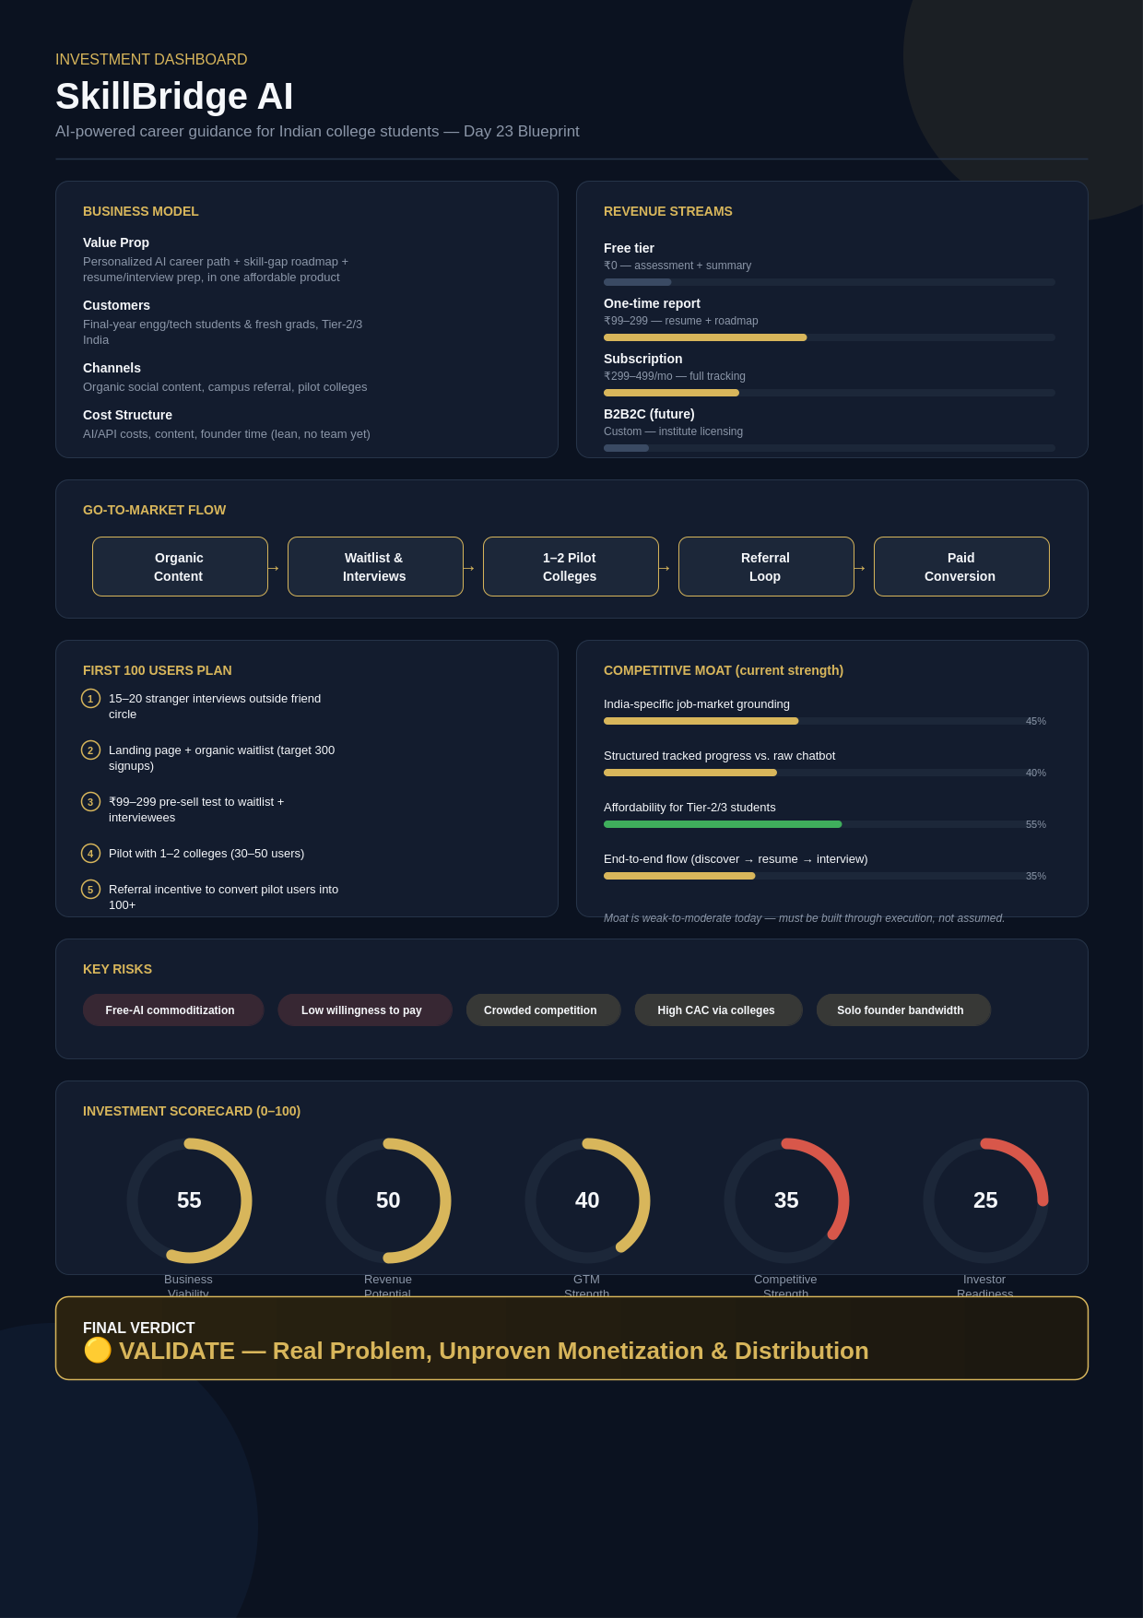

7. FOUNDER ACTION SHEET — TOP 10 ACTIONS
# | Action
1 | Conduct 15–20 stranger interviews outside your friend circle to remove sampling bias
2 | Launch a landing page and collect waitlist signups (target 300 organic in 2 weeks)
3 | Design and run a ₹99–299 paid pre-order test — cash is the only real validation signal
4 | Scope the MVP down to the single resume + roadmap wedge; resist building the full suite
5 | Pick a no-code/AI-API stack to build fast without needing a technical co-founder yet
6 | Secure 1–2 pilot colleges for a concentrated first cohort of 30–50 users
7 | Write messaging that clearly answers “why not just use ChatGPT?” in the first session
8 | Set up basic analytics to track activation, one-time-to-subscription conversion, and referral rate
9 | Design a referral/campus-ambassador mechanic to reduce future paid-acquisition dependence
10 | Set a Day-30/Day-60 Go/No-Go checkpoint tied to real payment and channel evidence, not opinions

8. SUSTAINABILITY VERDICT
🟡 VALIDATE
SkillBridge AI addresses a real problem in a large, growing market, but is not yet a proven business — no one has paid, and no repeatable acquisition channel exists. It can become sustainable, but only if the next 30–60 days are spent proving willingness-to-pay and a low-cost distribution motion, rather than building more product.

